ASSIGNMENT 102--WENDY NYASHA MAHENGA
CUSTOMER SERVICE IN THE HOSPITALITY INDUSTRY

- Four key features of good customer service

- A warm welcome: it is a friendly and genuine greeting that sets the tone for a positive experience. A warm welcome includes a smile and an eye contact, a friendly greeting for example hello, welcome or good evening, an offer for assistance for example can I help you with something?

- Prompt service: it is providing timely and efficient service to meet guests’ needs and exceed their expectations. It it involves quick responses to requests and orders and consistency in service quality and timing.

- Flexibility and adaptability: being able to adapt to changing situations and guests’ needs with a positive attitude. It also involves showing willingness to accommodate special requests or preferences, showing empathy and understanding when dealing with challenging situations.

- Respect and courtesy: treating guests with respect, kindness and courtesy at all times. It involves using polite language and expressions (for example thank you), respecting gusts’ privacy and personal space and also demonstrating a positive and inclusive attitude.

- Two examples of adapting customer service to different customers in a restaurant

- Example 1: couples
- Provide a quiet and intimate table setting.
- Offer a special romantic menu or wine list.
- Use discreet and attentive service to allow for for privacy.
- Anticipate special requests such as candle light or dessert sharing.
- Use a friendly personalized approach to enhance the romantic atmosphere.

- Example 2: senior citizens

- Offer assistance with with menus, orders and navigation.
- Provide clear and patient communication, speaking clearly and slowly.
- Offer recommendations for simpler or comfort food options.
- Use a gentle and respectful approach, address seniors by their preferred title, for example Mr/Mrs/Ms.
- Anticipate potential needs such as extra napkins or help with carrying items.

- Two benefits of good customer service to:

- Customer:
- Efficient resolution and satisfaction: this leads to quick solutions to problems or concerns and it also reduce frustrations and stress to a customer.
- Emotional benefits: this will help the customer from reduced stress and anxiety.

- Employee
- Motivation: recognizing and rewarding good customer service can motivate employees to continue delivering excellent service.
- Team building: collaborating to resolve customer issues can foster teamwork and camaraderie among employees.

(c} Business
- Revenue growth: satisfied customers are more likely to make repeat purchases and recommend the business to others, leading to increased revenue.
- Brand reputation: consistently delivering good customer service helps build positive reputation.

Task B

Date | occasion | communication | benefits
01/01/2024 | Guest orders a bottle of wine | Room land line speaking and listening. | - the customer does not have to leave their room to place an order.  - the customer can have their bottle delivered directly to their room.
30/03/2024 | Customer ordered rice and chicken and some juice | Face to face speaking and listening. | -Oder was deliver in time.  -Customer was satisfied .
02/04/2024 | Guest ordered fruit platter with a variety of fruits | Pointing gesture visually seeing what customer wants. | -Clear and concise.  -Business growth.
25/05/2024 | Guest ordered pizza | Face to face listening and assisting. | -Positive review.  -Happy customer.

TASK C

- Five key features of good personal hygiene and presentation are as follows
- Wash hands with soap.
- Sneeze while covering your face.
- Showering your body everyday.
- Brushing teeth.
- Avoid spitting everywhere. (spit into the sink)

- The importance of the above personal hygiene and presentation are as follows:

- Washing hands with soap:
-Food safety - Prevents the spread of food borne illness and contamination of food and drinks.
-Hygiene - Maintains a clean and hygienic environment, enhancing the overall guest experience.

- Sneeze while covering your face:
-Prevents spread of illness - Stops the spread of air borne pathogens, such as flu and cold viruses that can affect guests and colleagues.
-Prevents cross contamination - Prevents the spread of harmful bacteria and viruses from hands to surfaces, utensils and equipment.

- Showering your body daily:
-Personal hygiene - Maintains a clean and fresh body odour, ensuring a professional appearance and presence.
-Food safety - Prevents contamination of food and surfaces from unwashed body.

- Brushing teeth:
-Fresh breath - Ensures a fresh breath, enhancing interactions with guests and colleagues.
-First impression - A clean and healthy smile creates a positive first impression, setting the tone for a great guest experience.

- Avoid spiting everywhere:
-Cleanliness - Maintains a clean and hygienic environment for guests and colleagues.
-Professionalism - Demonstrates a professionalism and respectful attitude enhancing the establishment’s reputation.

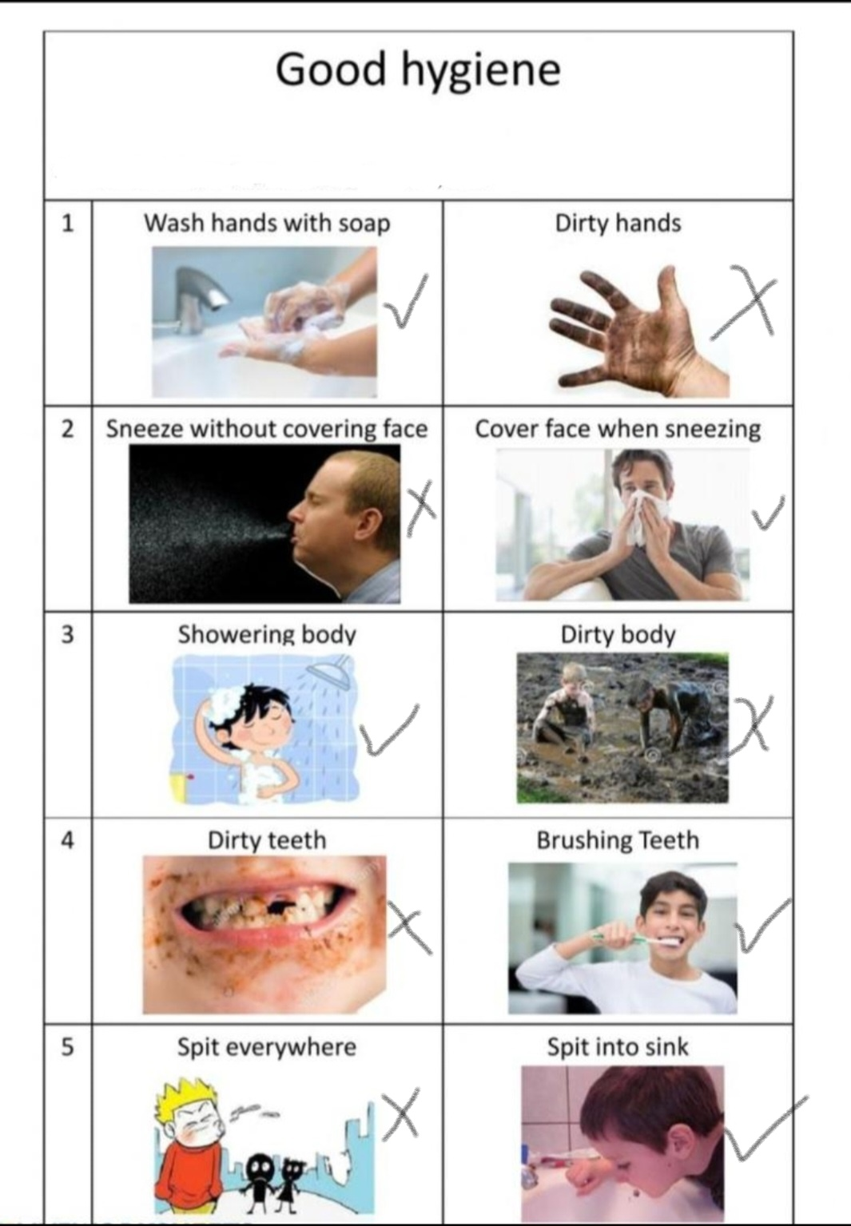
- Dress codes for at least two job roles:

- A chef’s dress code
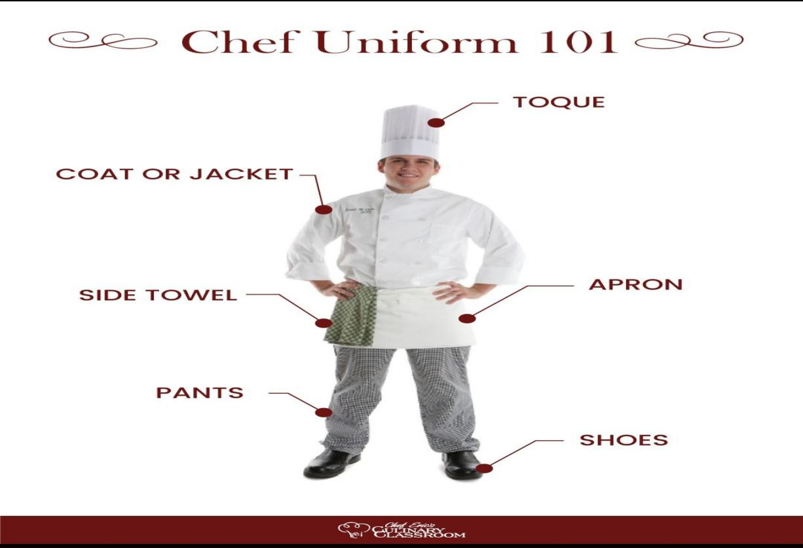

- A bar waiter’s dress code


